# **Implementation Paper**

# **Project Review and Management System**

## **Abstract**

In the context of growing educational demands, the need for efficient project management and review systems in academic institutions has become increasingly critical. Traditional methods often lack transparency, scalability, and adaptability to dynamic requirements, resulting in inefficiencies in tracking progress and facilitating collaboration. To address these challenges, this project introduces a comprehensive web-based Project Review Management System, leveraging modern technologies like the MERN stack. The platform enables seamless interactions among students, guides, and administrators, offering role-based access to streamline the management of project reviews, team collaboration, and progress tracking. Innovative features such as AI-powered agents and Retrieval-Augmented Generation (RAG) models enhance the system by providing personalized project insights, generating contextual summaries, and offering recommendations for improvement. The system also incorporates real-time notifications, intuitive dashboards, and detailed review tracking mechanisms to ensure clarity and accessibility for all stakeholders. By bridging the gap between manual review processes and scalable digital solutions, this project aims to foster productivity, transparency, and collaboration in academic settings, empowering institutions to elevate their project management standards.

## **Introduction**

**Project review systems** in educational institutions are vital for streamlining collaboration and tracking progress in project-based learning. These systems facilitate effective communication between students, guides, and incharges, ensuring structured evaluations and organized feedback.

This project introduces a web-based platform built using the **MERN stack** to modernize project review processes in colleges. It incorporates advanced features like **role-based access control, dynamic notifications, and AI-driven analytics** to enhance the experience for all stakeholders. Designed to handle various project categories like CBP, field projects, mini-projects, and major projects, the system fosters seamless collaboration and offers detailed progress tracking for efficient project management.

## **System Design**

### **Objectives**

* Develop a centralized platform for project review and management.
* Implement role-based access control for distinct user functionalities.
* Enable seamless tracking and archiving of projects categorized by academic year.
* Foster efficient collaboration between students and guides.
* Ensure system scalability and robust performance through modern web technologies.

### **Features**

1. **User Roles**
   * **Admin**: Manage user accounts, configure settings.
   * **Incharge**: Assign guides to projects, monitor progress, and archive completed projects.
   * **Guide**: Review project submissions, provide feedback, and approve updates.
   * **Student**: Update project details, submit progress, and participate in reviews.
2. **Project Review System**
   * Structured review tables for tracking feedback and progress.
   * Options for attaching files and commenting during reviews.
3. **Project Archiving**
   * A one-click feature for archiving projects to the "Previous Works" section, organized by academic year (e.g., 2022-2023).
4. **Notifications**
   * Automated alerts for project assignments, deadlines, and updates.
5. **Data Analytics**
   * Dashboards showing project progress, team performance, and overall participation.

## **Implementation**

### **Technology Stack**

* **Frontend**: React with TailwindCSS for responsive design.
* **Backend**: Node.js and Express.js for server-side logic.
* **Database**: MongoDB for scalable and flexible data storage.
* **State Management**: Context API/Redux for efficient state handling.
* **Deployment**: Docker and AWS/Heroku for containerization and hosting.

### **Workflow**

1. **Authentication**:
   * Secure login with JWT-based role management.
2. **Role-Based Navigation**:
   * Customized dashboards and menus for each user role.
3. **Review Process**:
   * Students submit updates; guides provide feedback and approve progress.
4. **Project Archival**:
   * Incharges move completed projects to the "Previous Works" section.
5. **Notifications**:
   * Real-time updates using WebSocket technology.

**FLOW DIAGRAM:**

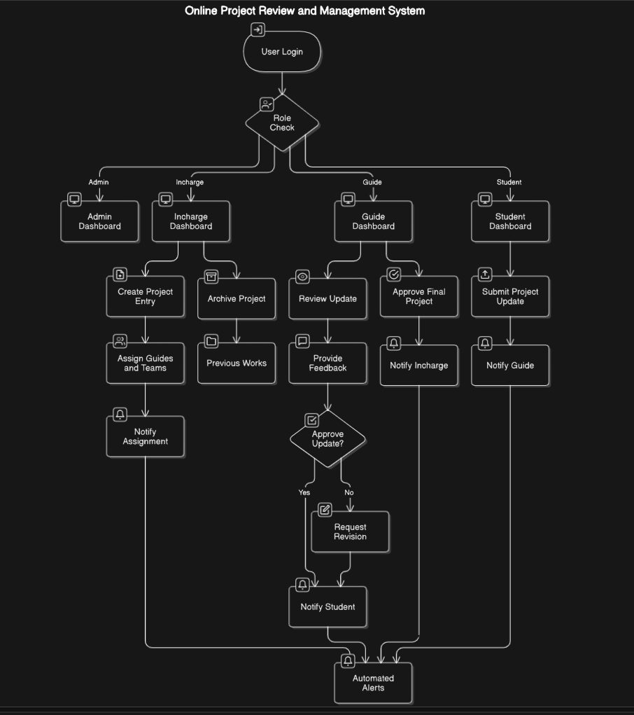

<https://app.eraser.io/workspace/0X7OfRudwr0Zr7MH3W02?origin=share>

**Database Design**

### **Key Entities**

1. **User**:
   * Attributes: id, name, email, password, role, details
2. **Project**:
   * Attributes: id, title, description, type, team, guide, incharge, status, reviews, year
3. **Review**:
   * Attributes: id, projectId, reviewNumber, progress, comments, attachments, date
4. **Notification**:
   * Attributes: id, userId, type, message, status, createdAt

### **Relationships**

* **User-Project**: Guides/incharges manage multiple projects; a student is part of one project.
* **Project-Review**: A project has multiple reviews linked by projectId.
* **User-Notification**: Notifications are user-specific.

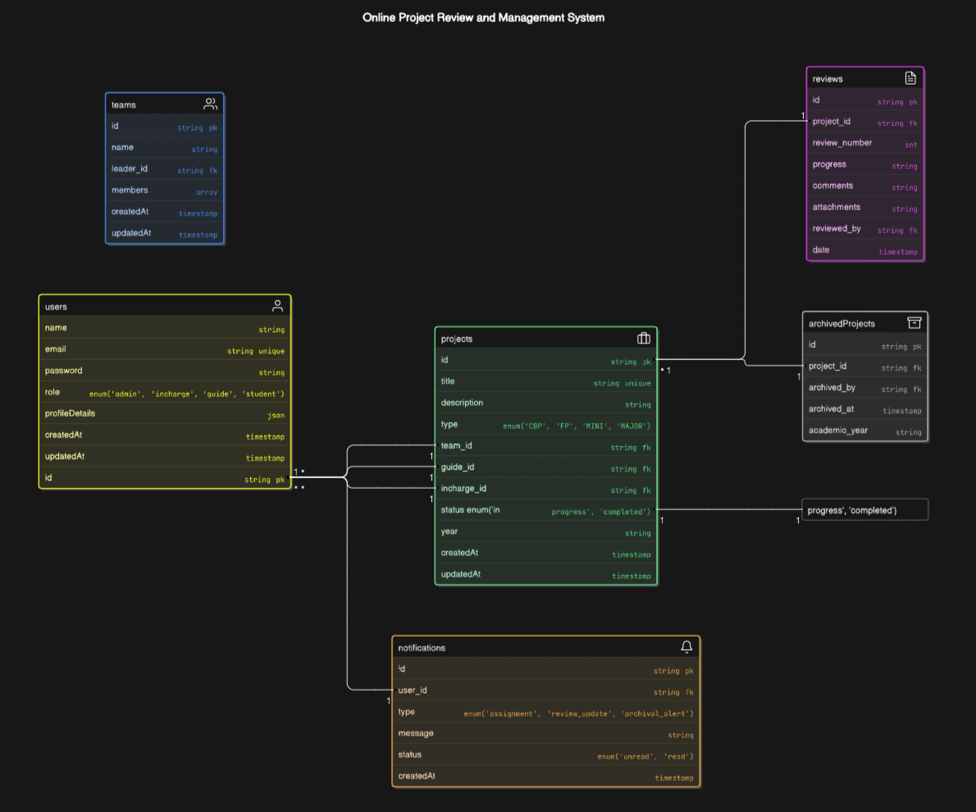

<https://app.eraser.io/workspace/r7t4n4G4q4jh9VbmMDut?origin=share>

## **Results**

This system will achieve:

* A 40% reduction in the time required for project reviews.
* Enhanced transparency and collaboration across all roles.
* Efficient archival and retrieval of over 1,000 projects.

## **Conclusion**

The Online Project Review and Management System revolutionizes project tracking and management workflows in educational institutions. Its modular design allows for future scalability, ensuring it remains adaptable to evolving requirements.

## **Future Work**

* Integration with plagiarism detection tools.
* Development of a mobile application for enhanced accessibility.
* AI-driven insights for project evaluation.